The Monthly Newsletter of Good Shepherd Evangelical Lutheran Church
Lindy, Nebraska
Pr. Thomas E. Jacobson: Email, tjacobson001@luthersem.edu; Home phone number in Menno, SD, 605-387-5196
The Rod and Staff
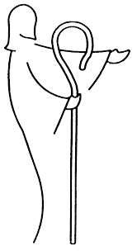
August 2016
Mining
In his hand are the caverns of the earth, and the heights of the hills are his also.
- Psalm 95:4

My family and I returned home very late in the evening on July 31. After the ice cream social on July 24, we loaded up the van for a week of vacation and headed north the next day. We visited my parents in southwestern Minnesota as well as our old community in northern Minnesota, a place close to my heart where I began my service as a pastor nearly ten years ago. It was fun to reconnect with members of my former parish and to see those congregations in action once again. Vacation is good and important every so often, but with a young family it is often more work to travel than it is to simply stay put! Being away for a while serves the important function of reminding us how important home really is. We truly love Menno and Lindy!

One thing I have learned over the years is that not all small town and rural areas in the country are the same. Unlike South Dakota and Nebraska, where corn and soybeans are the chief crops and where family farms are the norm, the land in northern Minnesota is not as suitable for such crops. Therefore, they raise a lot of sugar beets, sunflowers, and potatoes. Corporate farming is also much more common “up north,” which impacts the character of the communities. Also, agriculture is not the only important industry in that part of the country. Northern Minnesota relies heavily on logging and iron ore and taconite mining. Indeed, there is a region in northeastern Minnesota known as “the iron range.”

One day last week, we had the chance to visit the iron range. A huge iron ore mine near Soudan, Minnesota was retired from service in 1962 and then gifted to the state to be designated as a state park. Visitors can take a tour of the mine, which involves taking an elevator a half a mile underground and riding the mine rail cars. Were it not for artificial lighting, it would be pitch black down there. Visitors to the mine get to experience what miners lived with on a daily basis as they worked to bring tons of iron ore to the surface. They advise visitors to bundle up, as it is often less than fifty degrees that far underground.

The four of us decided to be adventurous and take the tour. The kids handled it well, though Henrik asked the tour guide to turn the lights on after he turned them off for a demonstration! While in the mine, I was reminded of the words of Psalm 95 quoted above: In his hand are the caverns of the earth, and the heights of the hills are his also.

These words of Psalm 95 are a part of the “Morning Prayer” service that Christians all around the world use every day. I have always found them powerful. As I mentioned last month, God’s presence encompasses everything, and one can never truly be lost from God for that reason. In the life of Jesus Christ, we see that God has come to earth, suffered and died, “descended into hell,” rose from the dead, and has ascended above all things, “filling all things” (Ephesians 4:10). “Hell,” whatever that means, is about as low as anyone can go. As the Psalm so beautifully expresses, God holds the greatest depths (the caverns) and the greatest heights (the mountains and hills) in His hand.

This is not only true of geography. It is true of our lives and experiences. Whatever our personal joys or personal hells might be, we believe that God is there to give us Himself in his Son Jesus Christ, who is there to give us forgiveness of sins, life, and salvation, the peace that only He can give. Thanks to be to God for His indescribable gift!

- Pr. T. E. Jacobson
Commemoration of the Saints
As you probably know, Lutherans do not venerate (pray to) special people called “saints.” Our Lutheran confessional documents speak against that practice. However, those same documents that prohibit the veneration of saints encourage Christian people to look to the lives of significant Christians of the past as a source of encouragement for our lives in the present.
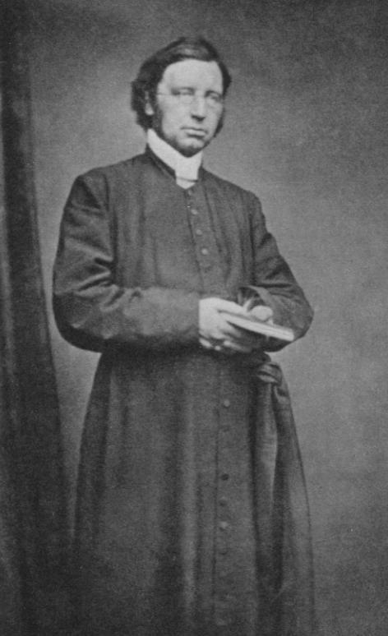
For August of 2016, the person is an English (Anglican) priest named John Mason Neale. He is often commemorated on August 6.
Neale was born in 1818, and he became a clergyman in the Church of England. His poor health prevented him from serving a local congregation, and so he instead became the warden of Sackville College, an institution devoted to serving the sick and the poor. He advocated for certain practices associated with the Roman Catholic Church to be reinstated in the life of the Church of England, for which he was at times attacked and viewed with suspicion.
He is best known, however, for his translations of hymns from the early Christian Church, such as “O Come, O Come, Emmanuel,” “Of the Father’s Love Begotten,” “All Glory, Laud, and Honor,” and “Come, You Faithful, Raise the Strain.” We are thankful for the life of this man, whose work continues to bless us through these beautiful hymns.
- Pr. T. E. Jacobson

Featured Hymn for August
Come, Ye Disconsolate
Lutheran Hymnal for Church and Home, 185
- Come, ye disconsolate, wherever ye languish; come to the mercy seat, fervently kneel! Here bring your wounded hearts, here tell your anguish; earth has no sorrow that heaven cannot heal.
- Joy of the desolate, light of the straying, hope of the penitent, fadeless and pure! Here speaks the Comforter, tenderly saying, “Earth has no sorrow that heaven cannot heal.”
- Here see the Bread of Life, see waters flowing forth from the throne of God, pure from above; Come to the feast of love; come, ever knowing Earth has no sorrow that heaven cannot heal.
- Thomas Moore, 1779-1852; verse 3, Thomas Hastings, 1784-1872
Note: Moore was an Irish poet and hymn writer whose works were published in 1816.
Monthly Watchword for August
Jesus says, “Salt is good, but if the salt has lost its saltiness, how will you make it salty again? Have salt in yourselves and be at peace with one another.”
- Mark 9:50 ESV
What is a “Watchword”?
The Moravian Church (a close cousin to Lutherans) began the practice in 1731 of selecting daily texts (Bible verses) for prayer and reflection, which continues to this day. Many Christians around the world use these Daily Texts as a part of their prayer life.
In addition to this, they began to select a theme verse for each week, called a “watchword.” You will notice in the bulletins for worship on Sunday mornings that I include that watchword for each week and begin worship by speaking that verse out loud, setting the tone for worship with that word from God.
The Moravian Church also selects theme verses for each month as well as for each year. For your own reflection, I will include the monthly watchword in the newsletter each month.

From Martin Luther’s Small Catechism:
The Lord’s Prayer: The Fifth Petition
And forgive us our trespasses, as we forgive those who trespass against us.
What does this mean?

We pray in this petition that our heavenly Father would not hold our sins against us and deny our prayers because of them. We know we have not earned, nor do we deserve, those things for which we pray. But we ask that he would grant us all things through grace, even though we sin every day and deserve nothing but punishment. And so we, too, will heartily forgive and gladly do good to those who sin against us.

Ushers for August:
Head Usher: Ushers:
Galen Guenther Ed and Tina Sage
Jamie Guenther Perry and LaVon Kolterman
Gary and Sherri Ermels

For Further Information on LCMC and the NALC: You can download and read the newsletters of both organizations at the following addresses: http://www.lcmc.net/newsletters and http://thenalc.org/newsletter/
Website: The web address is as follows: www.gselclindy.weebly.com
Connections Magazine: A part of the Lenten offering from this year will go toward subscriptions for Connections Magazine for each household in the congregation. Printed six times a year, this magazine includes informative and devotional articles for LCMC and NALC congregations. After the first year, we can remove names from the subscription list if anyone decides they would no longer like to receive it.
Schedule for Holy Communion: The Lord’s Supper will continue to be offered on the first and the third Sundays of each month unless otherwise noted. The first Sunday of the month, the Sacrament of the Altar will be received by kneeling (as you are able), and the third Sunday will be offered in a continuous line by intinction (dipping the wafer into the chalice of wine).
Birthdays, Anniversaries, and Email Addresses: Pr. Tom is compiling a list of email addresses for the congregation, and if you haven’t already done so, feel free to send him a message so that you can be included in announcements about congregational life, such as weather cancellations. Also, he is compiling a list of birthdays and anniversaries of members, so feel free to send any of this to his email: tjacobson001@luthersem.edu
Confirmation Class: Confirmation class will resume this September, with an informational meeting for new students (seventh grade) and parents on Wednesday, September 7 at 7:00 PM.
Watchwords for Sundays in August:
- Twelfth Sunday after Pentecost (August 7): “Fear not, little flock, for it is your Father’s good pleasure to give you the kingdom.” – Luke 12:32 ESV
Color: Green
- Thirteenth Sunday after Pentecost (August 14): “Let us run with endurance the race that is set before us, looking to Jesus, the founder and perfecter of our faith.” – Hebrews 12:1-2 ESV
Color: Green
- Fourteenth Sunday after Pentecost (August 21): “But the steadfast love of the Lord is from everlasting to everlasting on those who fear him.” – Psalm 103:17 ESV
Color: Green
- Fifteenth Sunday after Pentecost (August 28): “Let brotherly love continue.” – Hebrews 13:1 ESV
Color: Green

August 2016
Sun | Mon | Tue | Wed | Thu | Fri | Sat
 | 1 | 2 | 3  Pr. Tom in Lindy | 4 | 5 | 6
7  Worship, 10:30 with Holy Communion at altar rail  Green | 8 | 9 | 10  Pr. Tom in Lindy  Church council, 7:00 PM | 11 | 12 | 13
14  Worship, 10:30  Green | 15 | 16 | 17  Pr. Tom in Lindy  WOW/WNALC, 10:00 AM | 18 | 19 | 20
21  Worship, 10:30 with Holy Communion, continuous line  Green | 22 | 23 | 24  Pr. Tom in Lindy | 25 | 26 | 27
28  Worship, 10:30  Green | 29 | 30 | 31  Pr. Tom in Lindy

Good Shepherd Evangelical
Lutheran Church of Lindy
89039 539 Ave.
Bloomfield, Nebraska 68718

