The Monthly Newsletter of Good Shepherd Evangelical Lutheran Church
Lindy, Nebraska
Pr. Thomas E. Jacobson: Email, tjacobson001@luthersem.edu; Home phone number in Menno, SD, 605-387-5196
The Rod and Staff
February 2017
A Series on the Lutheran Reformation: Early Attempts at Reform
Remember your leaders, those who spoke to you the word of God.
Consider the outcome of their way of life, and imitate their faith. – Hebrews 13:7
As we began last month, so we continue this February with a series on the Lutheran Reformation. This year, 2017, marks the five hundredth anniversary of the movement that began in 1517, when Martin Luther and his colleagues began the work of refocusing the Church of their time on the central message of the Christian faith: the righteousness of God given to us through Jesus Christ, received through faith.
But as we observed last month, it is important to remember the long history that preceded the work that Martin Luther and his co-workers in Wittenberg, Germany accomplished. The goal of these Wittenberg Reformers was not to create a “new Church.” Instead, their work was devoted to clearing the fog of corruption and placing the focus of the Church in the right place.
And Martin Luther was far from the first person to answer this calling. In the centuries preceding the Lutheran Reformation, there were many voices in the Western Christian Church that called for reform. Religious orders and fellowships, along with universities of higher learning, were the source of many attempts at reforming church practice. We should not forget them, as Martin Luther himself was inspired by some of these examples.
In the Middle Ages, there were groups of monks known as “mendicants.” These mendicant monastic orders did not live in monasteries, but rather traveled around, ministering to people on their way. The most famous of these mendicant orders was the group known as the Franciscans, based on the ministry of Francis of Assisi in Italy. They challenged the wealth of popes and bishops, and they called people to live a Christ-like life of sacrifice and poverty.
Another group that called the Church back to its roots was the Waldensians, named after their leader Peter Waldo. This was a fellowship of laypeople in France. They also advocated for a return to simplicity in the Church, and they questioned the doctrine of purgatory (the idea that the souls of people need to be purified of sins before they enter God’s presence). They lifted up the Bible as the chief authority of the Church rather than the Church hierarchy, and for that they were punished.
There were other voices that called for reform in the years before Martin Luther. A man named John Wycliffe in England led such a movement. He translated the Bible into English as well as questioned some doctrines of the Church that he felt were not supported by the Bible. He was punished for his views, but he survived.
Taking inspiration from Wycliffe, a man named Jan (John) Hus in Bohemia (now the Czech Republic) stood for a similar message. He spoke against corruption among the clergy and argued that laypeople should be able to receive both bread and wine in the Lord’s Supper. He was called to answer for his teachings, being summoned to the Council of Constance in 1415. Though given the promise of safety, he was condemned and burned at the stake. A legend says that he remarked before his execution, “If you burn this goose, a hundred years later, God will raise up a swan.” The Czech word “Hus” actually means “goose.”
A century later, many people viewed Martin Luther as the “swan” that Hus spoke about. In later years, many Lutherans viewed Martin Luther as the one who was sent to fulfill the work that Jan Hus began. Luther was sometimes depicted in artwork with a goose at his side in honor of the work of Jan Hus a century before.
When we speak about the Reformation, we must remember that it is not ultimately about Martin Luther and that others worked for the same thing long before him. It is about the work of God the Holy Spirit in the Church, bringing us back to the central message of our faith when other things get in the way.
- Pr. T. E. Jacobson
_____________________________________________________
The season of Lent begins with Ash Wednesday, which falls this year on March 1. The season of Lent lasts for forty days (with the exception of Sundays), which symbolizes the forty days that Jesus was tempted in the wilderness. Lent concludes with Holy Week, when we remember the suffering and death of our Lord Jesus Christ.
During the season of Lent, we will have Wednesday evening worship at 7:00 PM. As in the past, Pr. Theresa from Menno and I will switch back and forth every other Wednesday. There will be no confirmation class during Lent, but students can use these Wednesday evenings as opportunities to fulfill their worship note requirements.

Commemoration of the Saints
Lutherans do not venerate (pray to) special people called “saints.” Our Lutheran confessional documents speak against that practice. However, those same documents that prohibit the veneration of saints encourage Christian people to look to the lives of significant Christians of the past as a source of encouragement for our lives in the present.
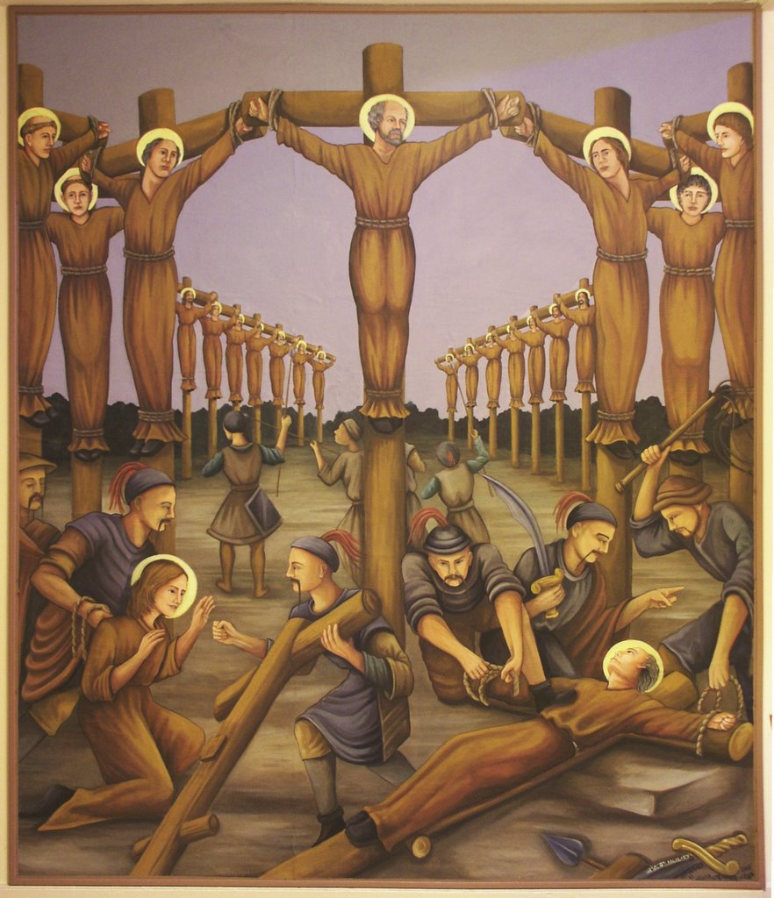
For February of 2017, we remember the martyrs of Japan.
The word “martyr” actually means “witness” in Greek. In time, the word “martyr” came to be applied to Christians who gave a witness to those around them by refusing to renounce their faith even when threatened with death. These martyrs gave their lives for their faith.
In the 1500s, Jesuit Catholic missionaries reached the country of Japan and established churches there. Initially, these churches flourished. But the authorities in Japan feared that the introduction of Christianity in their country would lead to a Western political takeover of their land. As a result, Christianity was repressed. On February 5, 1597, twenty-six Christians were executed by crucifixion in Nagasaki. Many Christians then went “underground” in Japan, and other incidents of execution of Christians would follow in the years to come until Christianity was legalized in the nineteenth century.
- Pr. T. E. Jacobson
______________________________________________________________________________

Worship Schedule

February 5: The fifth Sunday after Epiphany: Green

February 12: The sixth Sunday after Epiphany: Green

February 19: The seventh Sunday after Epiphany: Green

February 26: The Transfiguration of our Lord: White

March 1: Ash Wednesday: Purple
Featured Hymn for February 2017
Beautiful Savior
Lutheran Hymnal for Church and Home, 252
- Beautiful Savior, king of creation, Son of God and Son of Man! Truly I’d love thee, truly I’d serve thee, light of my soul, my joy, my crown.
- Fair are the meadows, fair are the woodlands, robed in flowers of blooming spring; Jesus is fairer, Jesus is purer, he makes our sorrowing spirit sing.
- Fair is the sunshine, fair is the moonlight, bright the sparkling stars on high; Jesus shines brighter, Jesus shines purer than all the angels in the sky.
- Beautiful Savior, Lord of the nations, Son of God and Son of Man! Glory and honor, praise, adoration, now and forevermore be Thine!
- Gesangbuch, Münster, 1677; translated, Joseph Seiss
Note: The source of this hymn is not clear, although some consider that it first appeared in a piece of music by a Swedish court musician who may have heard it originally in Silesia, now a region in Poland. Appropriate for many occasions, the tune is often sung as a Christmas hymn in Scandinavia, and the hymn is often used for the Sunday of the Transfiguration in North America.
Monthly Watchword for February 2017
“Whatever house you enter, first say, ‘Peace be to this house!’”
- Luke 10:5 ESV
Ushers for February:
- Head Ushers:
  - Reed and Cecilia Eckmann
- Ushers:
  - Scott and Christine Eisenhauer
  - Scott and Paula Veldhouse
  - Don and Bonnie Paulsen
  - Colin Kemp
For Further Information on LCMC and the NALC: You can download and read the newsletters of both organizations at the following addresses:
- http://www.lcmc.net/newsletters
- http://thenalc.org/newsletter/
Website: The web address is as follows:
- www.gselclindy.weebly.com
New Addition to Website: The North American Lutheran Church (NALC) has daily devotions written by various pastors and lay members. You can now access these daily devotions on the Good Shepherd website under “NALC Devotions and News.”
Sunday School: Please take advantage of this ministry of the congregation, which assists families in fulfilling their charge to pass on the faith to their children. Please also consider helping with the Sunday School ministry in this or the coming years

From Martin Luther’s Small Catechism:
The Sacrament of Holy Communion
What is the benefit of such eating and drinking?
It is pointed out in these words: “Given and shed for you for the forgiveness of sins.” Through these words the forgiveness of sin, life, and salvation are given to us in the sacrament; for where there is forgiveness of sin, there is also life and salvation.

February 2017
Sun | Mon | Tue | Wed | Thu | Fri | Sat
 |  |  | 1  Pr. Tom in Lindy  Confirmation class,  5:00 PM | 2 | 3 | 4
5  Sunday School, 9:30 AM  Worship, 10:30 with Holy Communion (altar rail)  Green | 6 | 7 | 8  Pr. Tom in Lindy  Confirmation class, 5:00 PM  Church council, 7:00 PM | 9 | 10 | 11
12  Sunday school, 9:30  Worship, 10:30  Green | 13 | 14 | 15  Pr. Tom in Lindy  Women’s meeting, 10:00 AM  Confirmation class, 5:00 PM | 16 | 17 | 18
19  Sunday School, 9:30  Worship, 10:30 with Holy Communion (continuous line)  Green | 20 | 21 | 22  Pr. Tom in Lindy  Confirmation class, 5:00 PM | 23 | 24 | 25
26  Sunday School, 9:30 AM  Worship, 10:30  White | 27 | 28

Good Shepherd Evangelical
Lutheran Church of Lindy
89039 539 Ave.
Bloomfield, Nebraska 68718

