The Monthly Newsletter of Good Shepherd Evangelical Lutheran Church
Lindy, Nebraska
Pr. Thomas E. Jacobson: Email, tjacobson001@luthersem.edu; Home phone number in Menno, SD, 605-387-5196
The Rod and Staff
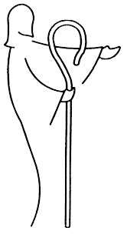
January 2017
A Series on the Lutheran Reformation: The Beginning
When the Spirit of truth comes, he will guide you into all the truth. – John 16:13
Over the last five hundred years, Lutherans have commemorated “Reformation centennials” in the years 1617, 1717, 1817, and 1917. After Martin Luther and his colleagues passed on, later generations of Lutherans wanted to find ways to remember the work that those people did in refocusing the Church of their time on the central message of the faith: the Gospel (good news) of Jesus Christ and our faith in Him. They looked at Martin Luther’s writing and distribution of the Ninety-five Theses in 1517 as the symbolic beginning of this time period called “the Reformation.” The legend says that Martin Luther posted these Ninety-five Theses on the door of the Castle Church of Wittenberg, which sparked debate. One thing led to another, and soon Luther became labeled a false teacher and an outlaw. The face of Europe and the whole world would change in the coming years.
The reality is that Martin Luther was not trying to start a revolution with his Ninety-five Theses. He was simply critical of the practice of selling and buying indulgences, which promised forgiveness of sins and reduction of the punishments of purgatory to the buyer. It would take a few more years before Luther’s thinking became fully developed and many more years before people started calling themselves “Lutherans.” But for the sake of simplicity, the year 1517 became the symbolic beginning of the work that Luther and others set out to do. But one of the most important things to remember is that reformation of the Church is not something that people accomplish. The Holy Spirit is the one who keeps the Church focused on its central mission. Reformation is God’s work, and that is why we use the color red on Reformation Sunday at the end of October. Red is used on the day of Pentecost, when we remember the coming of the Holy Spirit. Jesus says in John 16:13: When the Spirit of truth comes, he will guide you into all the truth.
And so the year 2017 marks five hundred years since the Reformation began. In celebration of this momentous event that changed the course of history in the Christian church, we will, throughout 2017 in this newsletter, be looking at the life of Martin Luther and the events that led up to the Reformation.
The Church of the Middle Ages
For the month of January, we focus on the years that preceded the Reformation, with a brief and admittedly simple historical overview. The “Great Schism” of 1054 AD had, at least on paper, divided Christianity into East and West, though “Eastern” and “Western” churches had been drifting apart from one another for some time. Those who lived in Western Europe were subject to the spiritual authority of the Pope (the Bishop of Rome) and many Christians lived within the realm of what was called “The Holy Roman Empire.” This realm included what we call today Germany and parts of France and Italy.
In those days, the lines between the church and state were often blurred. The Roman church wielded great power over the everyday lives of the nobility and commoners alike. Popes of the era claimed the right to crown and depose secular rulers. Under the power of interdict, popes could suspend all sacraments in a given territory to exercise political discipline. Officials of the church hierarchy had the power to tax church-held lands, which were ever expanding in all the territories of the Empire. In a practice known as simony, high church titles and offices (bishop, cardinal, etc.) were often sold for monetary gain. Financial corruption was rampant.
The church of the time was also very harsh on dissenters. One of the instruments used by Rome to root out and eliminate opponents was the Inquisition. Set up as a kind of investigating committee under the authority of the pope, the Inquisition’s mission was to maintain pure doctrine and identify false teachers. However, by using intimidation and torture to get confessions and in burning the condemned alive at the stake, the Inquisition served primarily as a weapon of fear for the authority of Rome.
Next month we’ll look at the early attempts at reforming the Church of Rome, prior to Martin Luther’s existence. As you can see, the church of the Middle Ages was often corrupt on many levels. What is the real purpose of the Church? Unfortunately, corruption can easily seep into Christian settings and denominations today. For this reason we must always pray for God’s guidance for His Church around the world, that we the Church strive to follow Him and that His will is done. May you all have a blessed and Happy New Year in 2017 AD!
- Pr. T. E. Jacobson
_____________________________________________________
During worship on Sunday, January 8, Good Shepherd will have the installation of council members for 2017.
January 8 will also be the second date for picture directory photos.
The annual meeting will be held on Sunday, January 15 after worship.

Commemoration of the Saints
Lutherans do not venerate (pray to) special people called “saints.” Our Lutheran confessional documents speak against that practice. However, those same documents that prohibit the veneration of saints encourage Christian people to look to the lives of significant Christians of the past as a source of encouragement for our lives in the present.
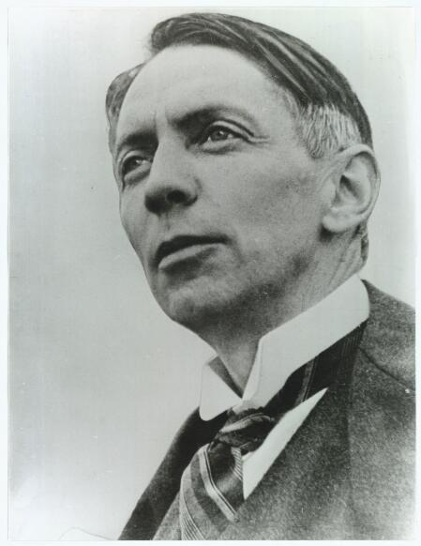
For January of 2017, we remember the life of Kaj Munk, a Danish pastor, patriot, and playwright (his first name rhymes with “high”).
Kaj Munk was born in 1898 and orphaned at the age of six. He was ordained in 1924 and became pastor at Vederso, one of the smallest parishes in Denmark. His writings discuss a wide variety of topics. His plays frequently deal with the eventual victory of the Christian faith despite its ineffective presentation by a weak church. Feared by the Nazis because his patriotic articles and sermons helped to strengthen the Danish resistance movement, he was arrested on January 4, 1944. The next day his body was found in a ditch. His martyrdom only increased the determination of the resistance movement to the Nazis in Denmark.
- Pr. T. E. Jacobson
______________________________________________________________________________

Worship Schedule

January 1: The First Sunday of Christmas: White

January 8: The Baptism of Our Lord: White

January 15: The Second Sunday after Epiphany: Green

January 22: The Third Sunday after Epiphany: Green

January 29: The Fourth Sunday after Epiphany: Green

Featured Hymn for January 2017
Bright and Glorious Is the Sky
Lutheran Hymnal for Church and Home, 131
- Bright and glorious is the sky, radiant are the heavens high, where the golden stars are shining. All their rays to earth inclining beckon us to heaven above, beckon us to heaven above.
- On that holy Christmas night through the darkness beamed a light; All the stars above were palling, all their luster slowly failing as the Christmas star drew nigh, as the Christmas star drew nigh.
- Sages from the East afar, when they saw this wondrous star, went to find the king of nations and to offer their oblations unto him as Lord and King, unto him as Lord and king.
- Him they found in Bethlehem, yet he wore no diadem; they but saw a maiden lowly with an infant pure and holy resting in her loving arms, resting in her loving arms.
- Nikolai F. S. Grundtvig, 1783-1872; translated, Jens Christian Aaberg
Note: Grundtvig wrote this Christmas/Epiphany hymn in 1810 between two episodes of mental distress. It is one of his first hymns and most beloved.
Monthly Watchword for January 2017
“And Simon answered, ‘Master, we toiled all night and took nothing! But at your word I will let down the nets.’”
- Luke 5:5 ESV
Ushers for January:
- Head Ushers:
  - Jeff Barger
  - Beth Barger
- Ushers:
  - Loren and Jane Yule
  - Ralph and Theresa Jessen
  - Jim and Marilyn Sage
For Further Information on LCMC and the NALC: You can download and read the newsletters of both organizations at the following addresses:
- http://www.lcmc.net/newsletters
- http://thenalc.org/newsletter/
Website: The web address is as follows:
- www.gselclindy.weebly.com
New Addition to Website: The North American Lutheran Church (NALC) has daily devotions written by various pastors and lay members. You can now access these daily devotions on the Good Shepherd website under “NALC Devotions and News.”
Sunday School: Resumes on January 8. Please take advantage of this ministry of the congregation, which assists families in fulfilling their charge to pass on the faith to their children

From Martin Luther’s Small Catechism:
The Sacrament of Holy Communion
Where is this written? (that Jesus’ body and blood are given with bread and wine)
Matthew, Mark, Luke, and Paul say: Our Lord Jesus Christ, on the night in which he was betrayed, took bread; and when he had given thanks, he broke it and gave it to his disciples saying: Take, eat, this is my body, which is given for you. Do this in remembrance of me. Again, after supper he took the cup, gave thanks, and gave it to them, saying: Take, and drink of it, all of you. This cup is the new testament in my blood, which is shed for you and for many for the forgiveness of sins. Do this, as often as you drink it, in remembrance of me.
January 2017
Sun | Mon | Tue | Wed | Thu | Fri | Sat
1  Worship, 10:30 AM with Holy Communion (altar rail)  Pr. Tom away  White  Eighth day of Christmas | 2  Ninth day of Christmas | 3  Tenth day of Christmas | 4  Pr. Tom in Lindy  Confirmation class, 5:00 PM  Eleventh day of Christmas | 5  Twelfth day of Christmas | 6  The Epiphany of our Lord | 7
8  Sunday School, 9:30 AM  Worship, 10:30; pictures this day as well  White | 9 | 10 | 11  Pr. Tom in Lindy  Confirmation class, 5:00 PM  Church council, 7:00 PM | 12 | 13 | 14
15  Sunday school, 9:30  Worship, 10:30 with Holy Communion (continuous line)  Annual meeting after worship  Green | 16 | 17 | 18  Pr. Tom in Lindy  Women’s meeting, 10:00 AM  Confirmation class, 5:00 PM | 19 | 20 | 21
22  Sunday School, 9:30  Worship, 10:30  Green | 23 | 24 | 25  Pr. Tom in Lindy  Confirmation class, 5:00 PM | 26 | 27 | 28
29  Sunday School, 9:30 AM  Worship, 10:30  Green | 30 | 31

Good Shepherd Evangelical
Lutheran Church of Lindy
89039 539 Ave.
Bloomfield, Nebraska 68718

