The Monthly Newsletter of Good Shepherd Evangelical Lutheran Church
Lindy, Nebraska
Pr. Thomas E. Jacobson: Email, tjacobson001@luthersem.edu; Home phone number in Menno, SD, 605-387-5196
The Rod and Staff
June 2016
The Birthday of the Lutheran Church
I will also speak of your decrees before kings, and shall not be put to shame.
- Psalm 119:46 NRSV

Memorial Day was observed on May 30 this year. When I was a pastor in northwestern Minnesota, I was frequently called upon to give the address at various Memorial Day assemblies in local communities. I have never served in the military, and so I struggled at first with deciding what to say. In the end, I spoke about my grandfather and his service in the US Army in the Pacific during World War II, but more generally I talked about the importance of remembering past events and the sacrifice of those who have gone before us in order to appreciate our own lives and the freedom we enjoy. While this remembering certainly applies to soldiers, sailors, airmen, and marines who gave their lives in battle, I believe it also applies to farmers, doctors, pastors, teachers, engineers, parents, and all others who have served in God’s world for our benefit.
And it also applies to those who have gone before us in our faith. This month of June marks the 486th anniversary of an important event for Lutherans. On June 25, 1530, Phillipp Melanchthon, Martin Luther’s close friend and co-worker, along with other committed lay people, presented a document called the Augsburg Confession to the Holy Roman Emperor Charles V. This took courage, as the Lutheran expression of faith was not legally recognized at that time. For this reason, this group of confessors began the document with a quote from the Bible listed above: I will also speak of your decrees before kings, and shall not be put to shame.
This document, still considered valid among Lutherans today, explained what these churches that would later be called “Lutheran” believed. It was called the “Augsburg Confession” because the place where this meeting took place was in the German city of Augsburg. To this day, many Lutheran institutions take their name from this document: Augsburg College, Augsburg Publishing House, and my alma mater of Augustana College (“Augustana” is the Latin form of the word “Augsburg”). Central to this document was the confession of faith found in article four:
Also they teach that human beings cannot be justified before God by their own strength, merits, or works, but are freely justified for Christ's sake, through faith, when they believe that they are received into favor, and that their sins are forgiven for Christ's sake, who, by his death, has made satisfaction for our sins. This faith God imputes for righteousness in his sight, as Paul says in Romans 3 and 4.
Because of this presentation of the Augsburg Confession to Emperor Charles on June 25, 1530, Lutherans have considered this date to be the birthday of the Lutheran Church. The purpose of the Augsburg Confession, however, was not to start a new religion, but rather to re-focus the church of that time on the truth. So, while we can celebrate June 25 as the birthday of our part of the Christian family, we remember that the true Church of Christ exists within other groups of Christians as well, wherever God’s Word is preached and faith is created.
Have a wonderful summer!
Grace and peace in Christ,
- Pr. T. E. Jacobson
Commemoration of the Saints
As you probably know, Lutherans do not venerate (pray to) special people called “saints.” Our Lutheran confessional documents speak against that practice. However, those same documents that prohibit the veneration of saints encourage Christian people to look to the lives of significant Christians of the past as a source of encouragement for our lives in the present. We should never assume that we cannot learn something from them. So, each month, I will highlight the life and witness of a significant Christian person from the past.
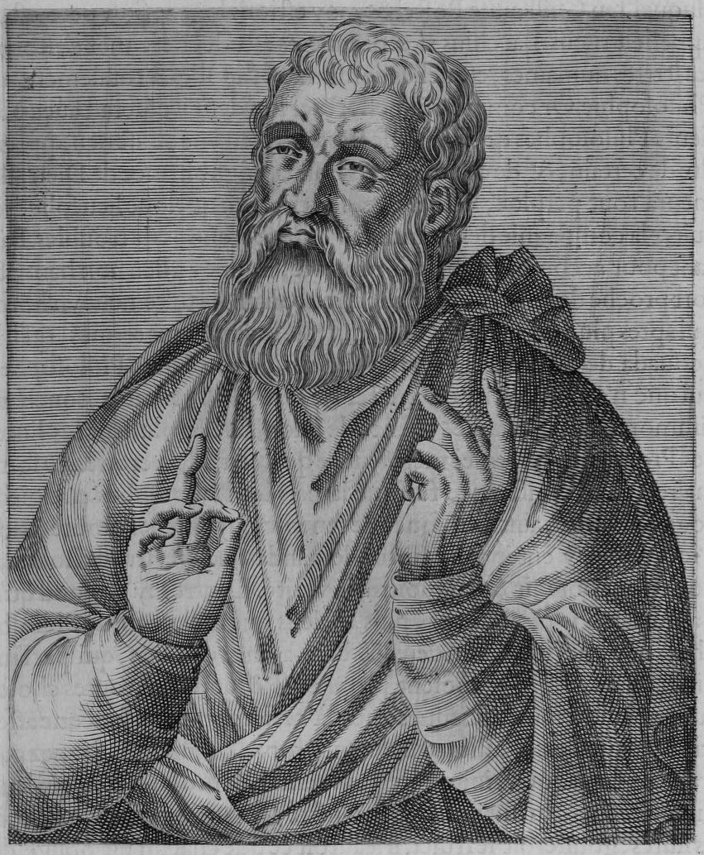
For June of 2016, the person is an early Christian theologian named Justin, often called “Justin Martyr.” He is often commemorated on June 1.
Justin was born around the year 100 to pagan (non-Christian, worshipping Roman gods) parents. After a long search for the truth, he became a Christian and taught at Ephesus and at Rome. He and some of his students were denounced as Christian and, upon their refusal to make a pagan sacrifice, were scourged and beheaded. The record of their martyrdom, based on an official court report, survives. Justin, while possessing no great philosophical or literary skill, was the first Christian thinker to attempt to reconcile the claims of faith and reason. His famous work is called The Apology, which was an attempt to demonstrate to pagan philosophers that Christian faith is reasonable.
- Pr. T. E. Jacobson
Monthly Watchword for June
The Lord is my strength and my might, and he has become my salvation; this is my God, and I will praise him, my father’s God, and I will exalt him.
- Exodus 15:2 NRSV
What is a “Watchword”?
The Moravian Church (a close cousin to Lutherans) began the practice in 1731 of selecting daily texts (Bible verses) for prayer and reflection, which continues to this day. Many Christians around the world use these Daily Texts as a part of their prayer life.
In addition to this, they began to select a theme verse for each week, called a “watchword.” You will notice in the bulletins for worship on Sunday mornings that I include that watchword for each week and begin worship by speaking that verse out loud, setting the tone for worship with that word from God.
The Moravian Church also selects theme verses for each month as well as for each year. For your own reflection, I will include the monthly watchword in the newsletter each month.
Featured Hymn for June
Breathe on Me, Breath of God
Lutheran Hymnal for Church and Home, 217
- Breathe on me, breath of God, fill me with life anew, that I may love what thou dost love, and do what thou wouldst do.
- Breathe on me, breath of God, until my heart is pure, until with thee I will one will, to do and to endure.
- Breathe on me, breath of God, unite my soul with thine, until this earthly part of me glows with thy fire divine.
- Breathe on me, breath of God, so shall I never die, but live with thee the perfect life of thine eternity.
- Edwin Hatch, 1835-1889
Note: This hymn was first published in a pamphlet entitled Between Doubt and Prayer in 1878 and was included in Henry Allon’s Congregational Psalmist Hymnal in 1886.

From Martin Luther’s Small Catechism:
The Lord’s Prayer: The Third Petition
Thy will be done, on earth as it is in heaven.
What does this mean?

The good and gracious will of God is done indeed without our prayer, but we pray in this petition that it will also be done among us.

How is this done?

God’s will is done when he hinders and destroys every evil design and purpose of the devil, the world, and our sinful nature that would keep us from hallowing his name and prevent the coming of his kingdom. And God’s will is done when he strengthens us and keeps us steadfast in his Word and in faith to the end of our earthly lives. This is his good and gracious will.

Ushers for June:
Head Usher: Ushers:
Reed Eckmann Richard and Phyllis Beckmann
Cecilia Eckmann Jerry and Sandy Ziegler
Dennis and Judy Friedrichsen
Tim and Deanna Jessen

For Further Information on LCMC and the NALC: You can download and read the newsletters of both organizations at the following addresses: http://www.lcmc.net/newsletters and http://thenalc.org/newsletter/
Website: The web address is as follows: www.gselclindy.weebly.com
Connections Magazine: A part of the Lenten offering from this year will go toward subscriptions for Connections Magazine for each household in the congregation. Printed six times a year, this magazine includes informative and devotional articles for LCMC and NALC congregations. After the first year, we can remove names from the subscription list if anyone decides they would no longer like to receive it. This announcement is simply to make you aware that you will be receiving this in the mail at some point in the near future.
Schedule for Holy Communion: The Lord’s Supper will continue to be offered on the first and the third Sundays of each month unless otherwise noted. The first Sunday of the month, the Sacrament of the Altar will be received by kneeling (as you are able), and the third Sunday will be offered in a continuous line by intinction (dipping the wafer into the chalice of wine).
Wedding Shower: The wedding shower for Brandon Barger will be held at the church on June 12 at 2:00 PM.
Ice Cream Social: The ice cream social will be held on Sunday, July 24 (instead of July 31).
Watchwords for Sundays in June:
Third Sunday after Pentecost (June 5): “Sing praises to the Lord, O you, his faithful ones, and give thanks to his holy name!” – Psalm 30:4 NRSV
Color: Green
Fourth Sunday after Pentecost (June 12): “We know that a person is justified not by works of the law but by faith in Jesus Christ.” – Galatians 2:16 NRSV
Color: Green
Fifth Sunday after Pentecost (June 19): “For dominion belongs to the Lord, and he rules over the nations.” – Psalm 22:28 NRSV
Color: Green

Sixth Sunday after Pentecost (June 26): “If we live by the Spirit, let us also be guided by the Spirit.” – Galatians 5:25 NRSV
Color: Green

June 2016
Sun | Mon | Tue | Wed | Thu | Fri | Sat
 |  |  | 1  Pr. Tom in Lindy | 2 | 3 | 4
5  Worship, 10:30 with Holy Communion at altar rail  Green | 6 | 7 | 8  Pr. Tom gone | 9 | 10 | 11
12  Worship, 10:30 (Pr. Bill Nelson-Loefke preaching and presiding)  Green | 13 | 14 | 15  Pr. Tom in Lindy  WOW/WNALC meeting, 10:00  Church council, 7:00 | 16 | 17 | 18
19  Worship, 10:30 with Holy Communion, continuous line  Green | 20 | 21 | 22  Pr. Tom gone | 23 | 24 | 25
26  Worship, 10:30 (Pr. Bill Nelson-Loefke preaching and presiding)  Green | 27 | 28 | 29 30  Pr. Tom in Lindy

Good Shepherd Evangelical
Lutheran Church of Lindy
89039 539 Ave.
Bloomfield, Nebraska 68718

